When Executives Stop Selling Stock,

a Big Deal Might Be Ahead

Pause in insider sales can be a clue for investors, past bids show
Amgen’s $28 billion bid for a smaller drugmaker was preceded by a pause in insider trading at the target company.

By Ben Dummett and Julie Steinberg Jan. 13, 2023 5:30 am ET

Investors learned of Amgen Inc.’s $28 billion bid for Horizon Therapeutics PLC in December. But a clue to a potential deal emerged months earlier, when insiders in the target company stopped selling stock.
The halt to stock sales by executives and directors at Horizon has been mirrored at some other big companies involved in recent deal making. The pattern shows why some hedge funds and other investors scrutinize activity by corporate insiders in the hope of identifying candidates for mergers and acquisitions, generating outsize gains in the process.
“When insiders who are selling regularly stop…it can definitely be a green flag, playing into the idea of a company working on a possible deal,” said Ben Silverman, research director at VerityData, which monitors trading activity by corporate insiders.
The U.S. Securities and Exchange Commission requires executives and directors to report share sales publicly, allowing investors to track their trading activity. A halt to selloffs can sometimes just imply a stock is undervalued, investors say.
But if a sector is consolidating, or a company is already rumored to be in play, and there is an unusual pause in insider sales, it can also suggest a potential deal is in the works. Insiders typically have to sit tight to avoid falling foul of insider-trading laws while they hold material information that isn’t yet public.
Horizon, which is Nasdaq-listed and based in Ireland, possesses established treatments for thyroid eye disease and other afflictions. These appealed to Amgen and other pharmaceutical heavyweights, which rely on acquisitions for new revenue to offset sales lost as key drugs lose patent protection.
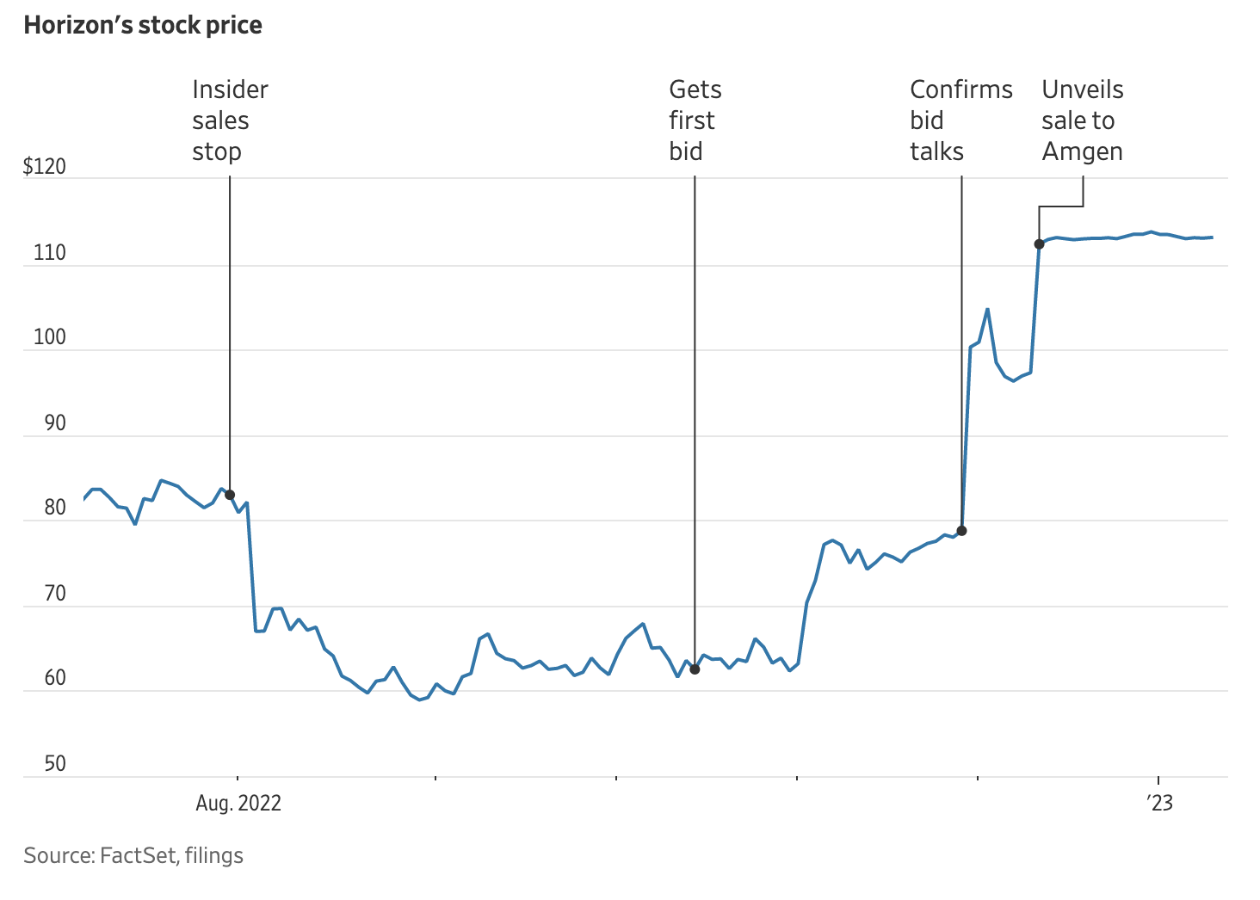
Horizon insiders stopped selling shares from the start of August, when weak second-quarter earnings pushed down the company’s stock. Before then, insiders had only refrained from selling for a whole calendar month three times in a period of more than three years, according to VerityData.
“The dip in selling had to do with our [second-quarter] results and the subsequent stock impact,” a Horizon spokesman said this week.
Insiders continued to hold off sales through October and much of November. On Oct. 15, Horizon privately received its first takeover approach, according to a later filing. In November, its shares surged after it released strong quarterly earnings. Later that month, it acknowledged being the subject of bid interest after the publication of a report in The Wall Street Journal.
In December, Amgen agreed to buy Horizon for $116.50 a share. In early August, after the second-quarter earnings release, Horizon shares had traded at around $67.
Investors such as Third Point LLC, the activist hedge-fund manager headed by Dan Loeb, Senvest Management LLC, a New York-based firm overseeing about $3 billion in assets, and hedge-fund firm D1 Capital Partners LP are among those looking at insider share sales to help identify potential investments.
In some cases, insider activity can offer clues about potential acquirers as well as sellers.
Unless businesses have a system of prearranged stock sales in place, executives typically confine trading to company-imposed windows, which open shortly after quarterly earnings are released and shut before the end of the next quarter.
For instance, at retailer Kroger Co., for all but one quarter between November 2018 to April 2022, insiders sold shares during each allotted trading window. But then that activity halted, VerityData data shows. A later filing showed Kroger first approached rival supermarket operator Albertsons Cos. about a possible takeover on April 25.
In October, Kroger unveiled a $24.6 billion acquisition of Albertsons, which had said in February that it would consider potential deals. Kroger declined to comment.
Tracking insider activity can sometimes help knock down bid rumors, too.
At the start of December, Nutanix Inc.’s Nasdaq-listed stock jumped 8% following reports that Hewlett Packard Enterprise Co. had shown interest in buying the cloud-computing provider. Then, starting around Dec. 16, at least four Nutanix insiders, including the company’s chief operating officer and chief executive, sold shares, filings show.
To Raj Vazirani, who runs New York-based Vazirani Asset Management LLC, this showed that Nutanix wasn’t in takeover talks, since the executives could have been barred from selling otherwise. He bet the stock price would fall, a wager that paid off after HPE said there were no talks on Dec. 23 and Nutanix shares fell about 8%.
“There is no way I would have bet against the deal absent the insider sale,” Mr. Vazirani said. “That was the main reason for initiating that short position, because that was a screaming signal.”
Nutanix didn’t respond to requests for comment.
To be sure, hedge-fund investors say that this is one factor they consider among many, and that it can be difficult to pinpoint the reasons behind selling patterns.
Companies’ use of so-called 10b5-1 plans, for example, can muddy the waters by making it harder to gauge the significance of trading activity. The plans allow corporate executives and directors to create schedules for future stock sales and purchases. That protects them from breaking insider-trading rules when stock is sold and they have material nonpublic information.
Write to Ben Dummett at ben.dummett@wsj.com and Julie Steinberg at julie.steinberg@wsj.com
Appeared in the January 14, 2023, print edition as 'Halt on Insider Sales Seen as Sign A Potential Deal Is in the Works'.

