Formula for Exam 1
Future value: FV=P*${(1+i)}^{n}$
Present value
$PV =\frac{CF}{ {(1+i)}^{n} }$
Fixed payment loan
$LV=\frac{FP}{(1+i)}+\frac{FP}{\left(1+i\right)2}+\frac{FP}{\left(1+i\right)3}+… +\frac{FP}{\left(1+i\right)n}$=FP*$\frac{1-{(1+i)}^{-n}}{i}$

$FP=$LV*$\frac{i}{1-{(1+i)}^{-n}}$
Coupon bond
$$P=\text{C}\text{*}\frac{1-{(1+i)}^{-n}}{i}+\frac{F}{\left(1+i\right)n}$$

$P_{c}=\frac{C}{i_{c}}{\begin{aligned} \\ i\end{aligned}}_{c}=\frac{C}{P_{c}}$
Current yield
i_{c} = C / P

one year discount bond, yield to maturity
$$i=\frac{F-P}{P}$$
Inflation and interest rate
i =i_{r} + π^{e}
i_{r} = i − π^{e}
Return
$$R=\frac{C+P_{t+1}-P_{t}}{P_{t}}$$

$$R=i_{c}+g$$

Expected Return
$$\text{R}\text{e}\text{ = }\text{p}\text{1}\text{R}\text{1}\text{+}\text{p}\text{2}\text{R}\text{2}\text{+}…+\text{p}\text{n}\text{R}\text{n}$$
Standard Deviation
$$σ=\sqrt{\text{p}\text{1}\text{(}\text{R}\text{1}\text{-}\text{R}\text{e}\text{)}\text{2}\text{+}\text{p}\text{2}\text{(}\text{R}\text{2}\text{-}\text{R}\text{e}\text{)}\text{2}\text{+}…+\text{p}\text{n}\text{(}\text{R}\text{n}\text{-}\text{R}\text{e}\text{)}\text{2} }$$
Expectation Theory
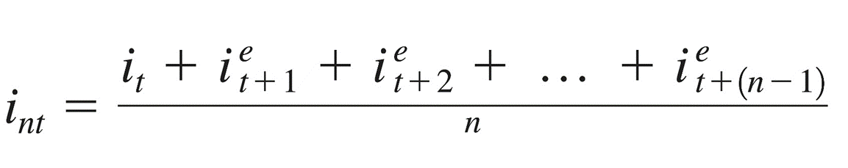

Forward Rate

