FAIRLEIGH DICKINSON UNIVERISY – ISHRTM

New Venture Management in the Hospitality Industry

CASE STUDY #5

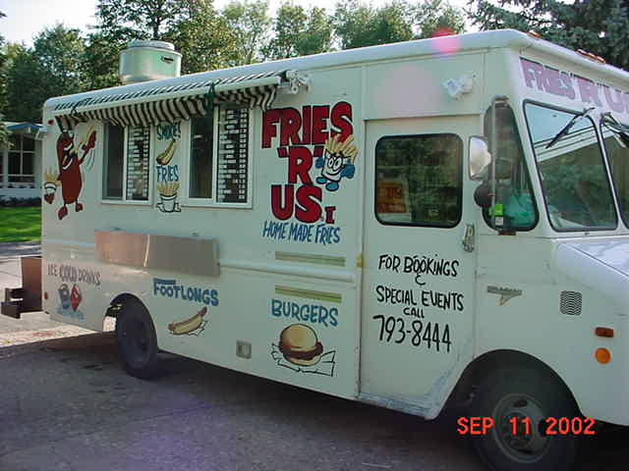

Mobile Food Service

http://www.concessiontrailersandcarts.com/

Case Study Challenge:
An idea was brought up to your venture capital group to buy or lease a food service truck and depending on the location (assuming appropriate licenses are in place), the annual cash flow from this business will result to a positive Net Present Value (NPV).

Get information on this business by visiting few sides that sell these types of trucks. For starters see attached link to one of the manufacturers:

http://www.californiacartbuilder.com

