FAIRLEIGH DICKINSON UNIVERISY – ISHRTM

Advanced New Venture Management in the Hospitality Industry

CASE STUDY #4

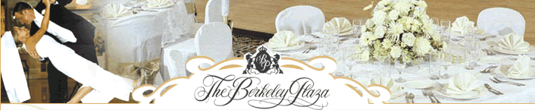

The Berkley Plaza

Berkley Heights, NJ

http://www.berkeleyplaza.com

Case Study Challenge:

The Berkeley Plaza, a family owned and operated banquet hall, has asked your Company to see if you are interested in buying the property and the business. The owners of are asking for $4,500,000.

Property Description

The Berkeley Plaza is a full service caterer in New Jersey that can accommodate from 75-350 with packages to suit every budget.

The building includes two private and distinct ballrooms. From the classic elegance of the Plaza Ballroom, which features a spiral staircase and a large crystal chandelier; to the soft colors decor in the Crystal Ballroom highlighted with atrium windows. Both rooms have large dance floors, and separate cocktail hour rooms for your guests as well as separate bridal suites.

The picturesque gazebo with its manicured garden is perfect for outdoor ceremonies and photo memories.

More Info could be found on the website at www.berkeleyplaza.com including virtual tour, menus, pictures and other.

The Berkley Plaza
Income Statement
 | 2007 | 2008 | 2009
Revenues
Catering | 5,550,000 | 5,439,000 | 5,819,730
Commissions | 13,050 | 12,100 | 14,130
Other | - | - | -
Total Revenues | 5,563,050 | 5,451,100 | 5,833,860
Revenue Growth |  | -2.0% | 7.0%
Cost of Revenues
Labor | 1,110,000 | 1,142,190 | 1,338,538
Food & Beverage | 1,942,500 | 2,012,430 | 2,211,497
Overhead | 277,500 | 217,560 | 320,085
Total Cost of Revenues | 3,330,000 | 3,372,180 | 3,870,120
Operating Costs
Marketing/Sales | 278,153 | 272,555 | 291,693
Administrative | 166,892 | 163,533 | 175,016
Energy/Utility Costs | 333,783 | 327,066 | 350,032
Other General | 83,446 | 81,767 | 87,508
Total Operating Expenses | 778,827 | 763,154 | 816,740
EBITDA | 1,454,223 | 1,315,766 | 1,146,999
Depreciation | 210,100 | 214,302 | 218,588
EBIT | 1,244,123 | 1,101,464 | 928,411

