Lecture 1
INTRODUCTION TO FINANCE
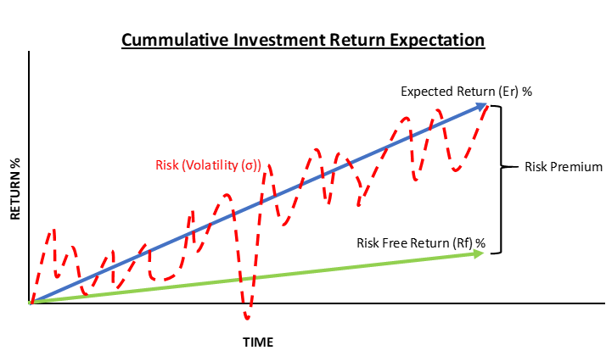
Starting with the basics, I will say that before someone is looking to invest in stocks, bonds, or any other asset class, he or she needs to consider the four following factors:
- Measuring the expected return of the investment
- Quantifying the risk of such investment
- Setting the time to exit the investment
- Exploring ways to allocate to achieve portfolio risk diversification, investment efficiency, and optimization

Initial Investment grew by 10% since last year:

$100 x (1+ growth rate) = 100 x (1+.10) = 100 x 1.10 = 110

Present Value = 100

Growth Rate = Rate of Return = 10%

Time = One Year

Future Value =? = 100 x 1.10 = 110

To invest in two years = grow by in 2 years by 10% per years:

FV = 100 x (1+.10)) x (1+.10) = 100 x (1+.10)² = 100 x (1.21) = 121.

FV = PV(1+i)^{t}

So FV = $\frac{PV}{{(1+i)}^{t}}$

Measuring Return if you know the present value and the future value:

Rates of Return: Holding Period Return (HPR)
The first basic measurement of return does not consider the length of time that the return was achieved and is called the holding period return (HPR). HPR is focused on what the net return over the investment life. It measures the rate of return from the time the investor initiated the investment until the investment was realized, basically the rate of return for the holding period whether it is 1 month or 5 years. The ratio in its most basic form is
HPR = $\frac{CF}{I}$
where CF is the cash flow (inflow and outflow) during the investment period and I is the initial investment. For example, if an investor buys the stock for $100 and sells it for $120 and during the investment he or she received $2 in dividends, then the cash flow on the numerator is $120 of proceeds for selling the stock plus $2 of cash dividends received (cash inflow) minus the initial investment of $100 (cash outflow), and the net cash flow is $22 ($120 + $2 - $100). The HPR will be calculated by dividing the net cash flow of $22 by the initial investment of $100 resulting in a 22% return:
$$\frac{\left(120-100+2\right)}{100}=\frac{22}{100}=0.22=22\%$$
For a quick analysis of expected return, the HPR ratio, which represents the relationship between cash flow to the initial investment, can be found in many applications on various asset classes. For example, let’s assume the investor is interested in buying a bond that has an 8% per-year coupon rate, or annual interest income of $80 on a $1,000 bond, and the secondary market price of the bond is 95% of par, or $950. To calculate the expected return or the current yield (CY) in bond talk, the numerator of $80, representing the annual expected payment or cash flow, and the denominator of $950, representing the purchase price of the bond or initial investment, will calculate the expected annual return of 8.42%:
$$CY =\frac{CF}{I}=\frac{Annual Coupon Payment}{Market Price of the Bond}=\frac{80}{950}=0.0842=8.42\%$$
In many cases an expected return (discussed in depth later) that the investor sets as a target before making the investment determines the initial investment needed to achieve the expected cash flow. Using the bond example, the annual coupon payment of $80 is already set based on the bond agreement (indenture), but in this case the investor desires a 10.0% return based on new measured risk assessment of this bond; then to achieve 10.0% the numerator will be $80 divided by the expected return of 0.10 or 10.0%, calculating the initial investment needed $800.00 by solving for investment (I):
$$since CY =\frac{CF}{I}, then CF=\left(CY\right).\left(I\right) and I= \frac{CF}{CY}= \frac{80}{.10}=\$800.00$$
This relationship between cash flow, investment, return, and time is the basic variable in calculating “time value of money,” discussed in many finance textbooks, where the cash flow is the expected cash flow to be received in the future or future value (FV) minus the investment, the investment representing today’s investment or present value (PV) and return or expected return representing the interest rate (i) at a set time (t). This ratio of HPR can translate to the concept of “time value of money”:
$$HPR=\frac{CF}{I} or i=\frac{(FV-PV)}{PV } or i=\frac{FV}{PV}-\frac{PV}{PV} or i=\frac{FV}{PV} -1$$
$$then present value (PV) is$$
$$PV=\frac{FV}{\left(1+i\right)} for in one year$$
$or PV=\frac{FV}{{\left(1+i\right)}^{t}} in future year t$
and to calculate future value (FV)
FV = PV ${\left(1+i\right)}^{t}$
[Insert boxed text here
Excel formulas for present value, future value and rate of return:
= PV (rate, years, future value)
=FV (rate, years, present value)
=Rate (years, future value, -present value)
End boxed text here]
When trying to calculate the annual rate instead of the total rate of return for the entire investment hold period, then this rate is referred to as the internal rate of return, or IRR, covered in the next section.

Rates of Return: Annual Rate of Return (ROR) and Internal Rate of Return (IRR)
The concept of time value of money is mostly used for calculating the annual rate of return as the basis of comparing such return to other years, or to the risk-free rate to establish the risk premium, explained in later chapters. The relationship between today’s investment to future expectation for given years will result in an annual rate of return.
Starting with the basic time value of money formula of present value, the formula is
$PV=\frac{FV}{{\left(1+i\right)}^{t}} in future year t$
where it calculates the initial investment needed to achieve at a set future payoff in year “t” at the annual rate of return (ROR) or “i.” For example, what do you need to invest today to receive $100 in 5 years at 5% return per year? Based on the calculation, you need to invest $78.35:
$$pv=\frac{\$100}{{\left(1+0.05\right)}^{5}}=\frac{100}{1.2763}=\$78.35$$
If we know what we need to invest today at an annual rate “I,” and we are trying to calculate what the investment will be “t” years, then the formula is
FV = PV ${\left(1+i\right)}^{t}$
For example, if you invest $100 today for 5 years and expect 5% return per year, your investment will be calculated to grow to $127.63:
$$Fv=\$100{\left(1+0.05\right)}^{5}=\$100 \left(1.2763\right)=\$127.63$$
To then reverse this formula to calculate the annual rate of return (ROR) the formula is

${\left(1+i\right)}^{t}=\frac{FV}{PV}$ , then $i$ = $\sqrt[t]{\frac{FV}{PV}}$ - 1
For example, if you invest $100 today and expect in 5 years a payoff of $127.63, what is the rate of return per year? The calculation shows 5.0% annual return:
ⅈ=5127.63100$ⅈ=\sqrt[5]{\frac{127.63}{100}}-1=1.05-1=0.05=5\%$
For an investment where the investor receives annual cash flows during the investment period, the ROR calculation is a little more challenging than a one-time payment in the future. If the cash flows from the investment are the exact same amount for every year, then the annual cash flows over the investment represent the annual return, including the original investment amount, similar to a bond investment where the investor receives annual or semi-annual fixed payments and a one-time principal payment at maturity of the bonds or early repayment (sometimes referred to as redemption).
For example, if we invest $100 to an investment that pays $5 fixed per year for 5 years plus, receiving the initial investment of $100 in year 5, then the annual (ROR) will be 5%.
The more challenging calculation is if the payment is different every year, so the annual rate of return must be weighted based on size and the year paid. This type of rate return method is the internal rate of return. It’s challenging because each year the investment would have different payoffs and sometimes negative numbers. The best approach to calculate the IRR is using spreadsheet analysis. The formula that will be used throughout this book is IRR (CF₀, CF₁, CF₂, CF₃ . . . CF_{t}).

