**INTRO TO BINOMIAL OPTION PRICING MODEL**

Binomial Option Pricing Model (BOPM) was invented by Cox-Rubinstein in 1979. It was originally invented as a tool to explain the Black-Scholes Model to Cox's students. However, it soon became apparent that the binomial model is a more accurate pricing model for American Style Options. The binomial model is thus named as it returns 2 possibilities at any given time. Therefore, instead of assuming that an option trader will hold an option contract all the way to expiration like in the Black-Scholes Model, it calculates the value of that trader exercising that option contract with every possible future up and down moves on its underlying asset, reflecting its effects on the present value of that option, thus giving a more accurate theoretical price of an American Style option.   
  
The binomial model produces a binomial distribution of all the possible paths that a stock price could take during the life of the option. A binomial distribution, or simply known as a "Binomial Tree", assumes that a stock can only increase or decrease in price all the way until the option expires and then maps it out in a "tree". Here is a simplified version of a binomial distribution just for illustration purpose :

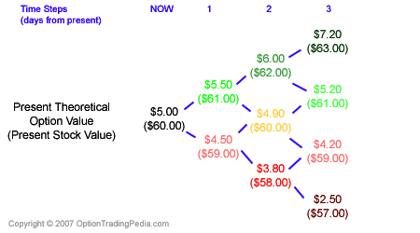  
It then fills in the theoretical value of that stock's options at each time step from the very bottom of the binomial tree all the way to the top where the final, present, theoretical value of a stock option is arrived. Any adjustments to stock prices at an ex-dividend date or option prices as a result of early exercise of American options are worked into the calculations at each specific time step .

**Advantage Of The Binomial Option Pricing Model**   
It can more accurately price American Style Options than the Black-Scholes Model as it takes into consideration the possibilities of early exercise and other factors like dividends.   
  
**Disadvantage Of The Binomial Option Pricing Model**   
As it is much more complex than the Black-Scholes Model; it is slow and not useful for calculating thousands of option prices quickly.

***Example:***



|  |  |  |  |  |  |
| --- | --- | --- | --- | --- | --- |
|  |  | Assume Call option is mispriced at = | $ 6.50 |  |  |
|  |  | Using the Hedge ratio you get to the following strategy= | 3.0x |  |  |
|  |  |  |  |  |  |
|  |  |  | **Initial** | **At S1 =** | **At S1 =** |
| **Sequence** | **Strategy** |  | **CF** | **$ 90.00** | **$ 120.00** |
| FIRST | Write 3 Calls at cost = | | $ 19.50 | $ - | $ (30.00) |
| SECOND | Buy one share = | | $(100.00) | $ 90.00 | $ 120.00 |
| THIRD | Borrow the difference at 10% = | | $ 80.50 | $ (88.55) | $ (88.55) |
|  | **Total** |  | **$ -** | **$ 1.45** | **$ 1.45** |
|  | Present Value= | | $ - | $ 1.32 | $ 1.32 |
|  | Per option profit | |  | $ 0.44 | $ 0.44 |
|  |  |  |  |  |  |
|  |  |  |  | Note : Exactly the amount that the option is mispriced $6.50 - $6.06 = | $ 0.44 |
|  |  |  |  |  |  |