FINAL EXAM REVIEW
- INPUT: 2 YEARS OF BALANCE SHEET AND 2 YEAR OF INCOME STATEMENT
OUTPUT: BUILD A CASH FLOW STATEMENT AND RATIO ANALYSIS (CHAPTER 15)

SPREADSHEET: CASE #1: CELERITY TECHNOLOGY

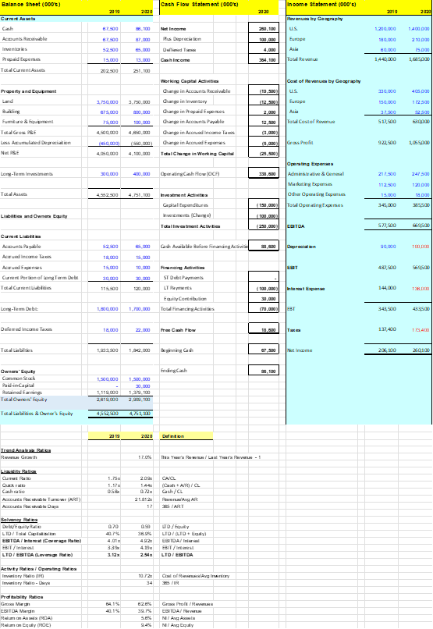
- INPUT: CASE STUDY
OUTPUT: BUILD THE TRANSACTION SOURCES AND USES AND CALCULATE WACC

SPREADSHEET: CASE #2: ALEXANDRIA HOTEL

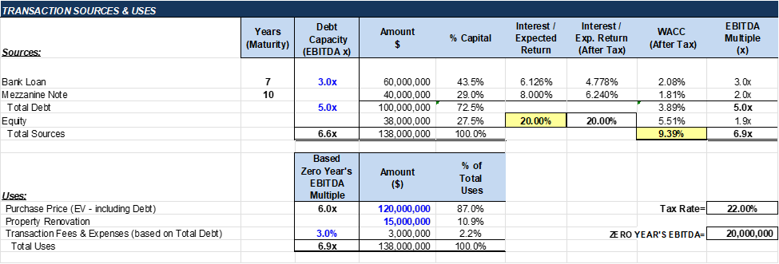

- INPUT: DEBT INFORMATION (DEBT AMOUNT, INTEREST (floating or Fixed), AMORTIZATION SCHEDULE
OUTPUT: DEBT SCHEDULE

SPREADSHEET: CASE #2: ALEXANDRIA HOTEL

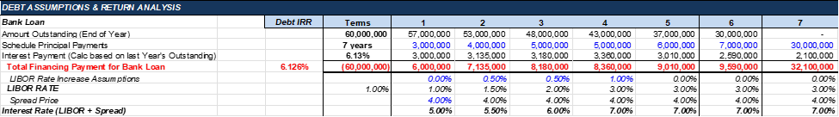

- INPUT: OPERATING ASSUMPTIONS
OUTPUT: BUILD INCOME STATEMENT AND DCF PROJECTIONS

SPREADSHEET: CASE #2: ALEXANDRIA HOTEL

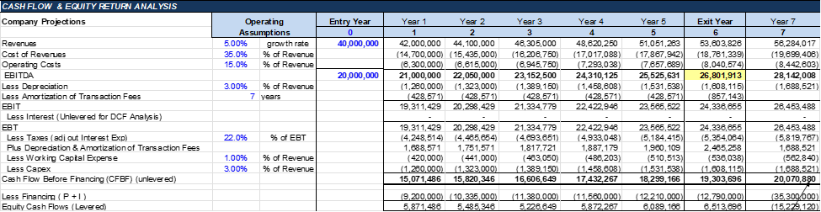

- INPUT: CASH FLOWS
OUTPUT: EQUITY NPV, TERMINAL VALUES, IRRs, CAPM

SPREADSHEET: CASE #2: ALEXANDRIA HOTEL
FINAL PROJECT CONCEPTS (TERMINAL VALUE, PUBLIC COMPANY WACC, CAPM)
