LECTURE 6
Portfolio Performance Evaluation

CHAPTER 24
Considering Factors Before Investing:
- Expected Risk – set-up expectation
- Measure Risk – quantify risk
- Time – set time for expectation
- Allocation (between Risk and Non-Risk)- achieve efficiency and then optimization - CAL
Measurement:
- Compare vs historical performance
- Compare vs Market performance / Vs other portfolios
- Compare to Expectation (Realized Returns vs Expected Returns) -

- Concepts of Return:
- HPR concepts Vs IRR - basic CF / Initial Investment
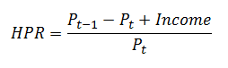
- Arithmetic Rate of Return

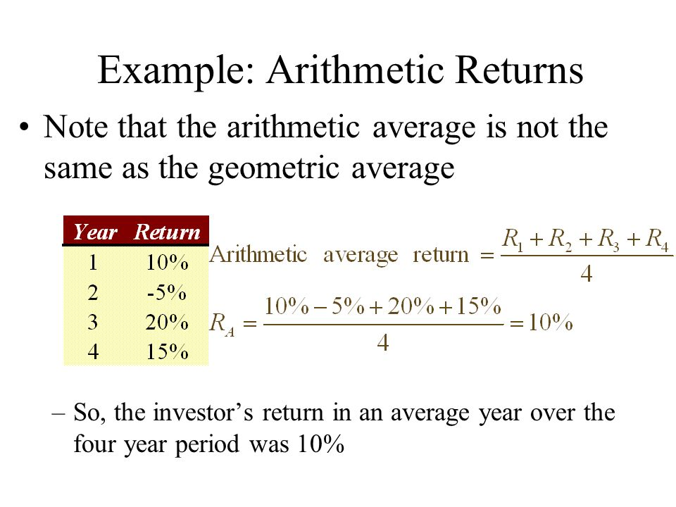

- Geometric Rate of Return
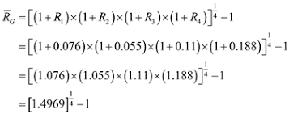

- Measurement of Risk/Return and Analyzing the Relationship

- CAPM (Achieving risk adjusted market returns)

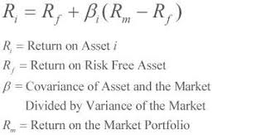

- Sharpe Ratio (achieving return optimization)

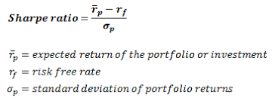

- Treynor Ratio

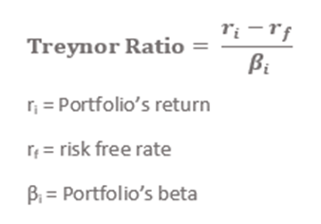

- Jansen’s Alpha – Seeking Alpha (Alpha = Actual Return - CAPM )

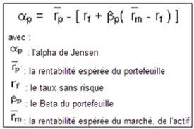

- Modiagliari Squared (M^2) (adjusting for Standard Deviation Return)

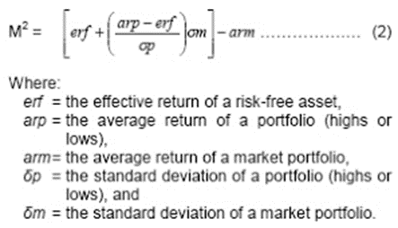

FINAL EXCEL PROJECT SPREADSHEET -

