**MIDTERM REVIEW:**

1. FINANCIAL ANALYSIS (Input: 2 years of Balance Sheet / 2 years on Income Statement) 25 points
   1. Preparation of Cash Flow Statement (Homework 15.2)
   2. Calculate Financial Ratios



1. PROJECTIONS (15 points)
   1. Prepare 5-year projections for Income Statement – down to EBITDA (Homework 16.1)



1. DEBT SCHEDULES AND BANK PROFORMA ANALYSIS (30 points)
   1. INPUT: Debt Outstanding, LIBOR Spread, Debt Payments, LIBOR and LIBOR Increases
      1. Build a Debt Schedule with interest rate calculation using LIBOR and LIBOR Spread



* 1. INPUT: Pre-transaction Balance Sheet and Transaction Sources & Uses
     1. Build the Transaction Debt and Credit Adjustments
     2. Post Transaction opening Balance Sheet



1. VALUATION ANALYSIS (30 points)
   1. Methods 1-5 public traded company valuation
      1. Method 1: EV = Eq + D – C and EQ = SO x SP

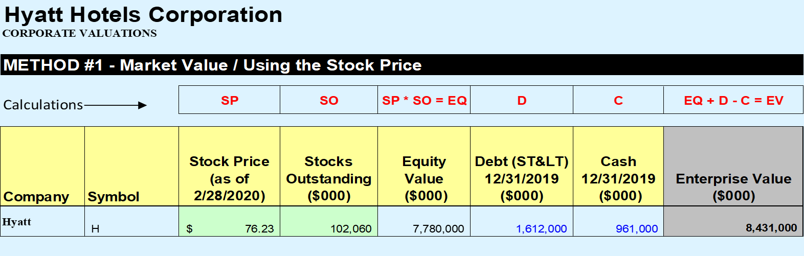

* + 1. Method 2: Intrinsic Value (Future Stock + Div )/CAPM

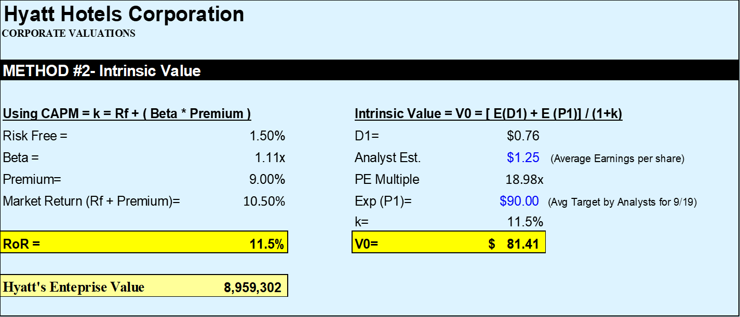

* + 1. Method 3: DDM V = Div / (CAPM – Growth rate)

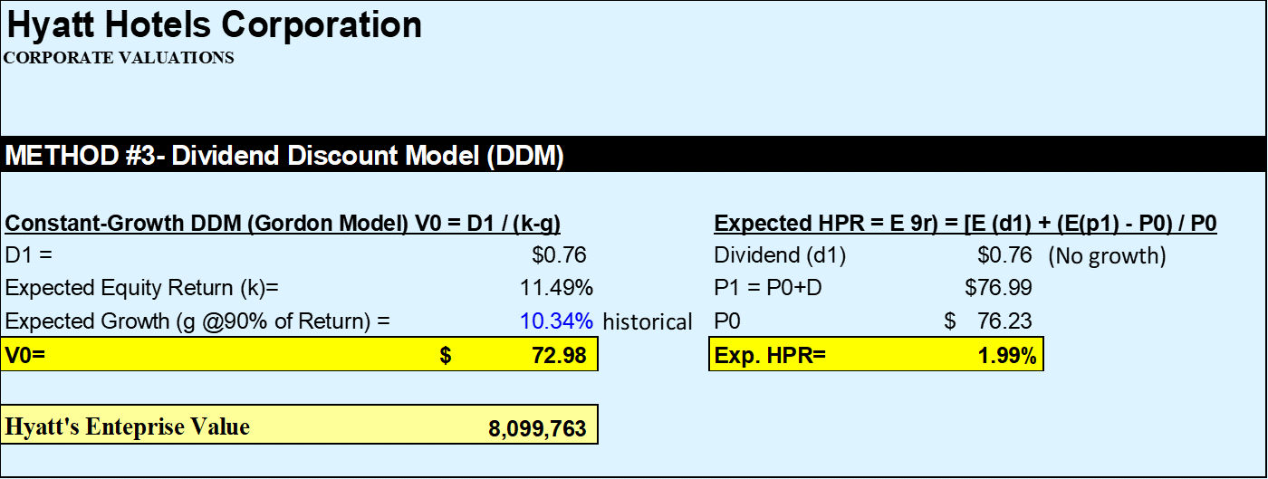

* + 1. Method 4: EBITDA Trading Multiple Method

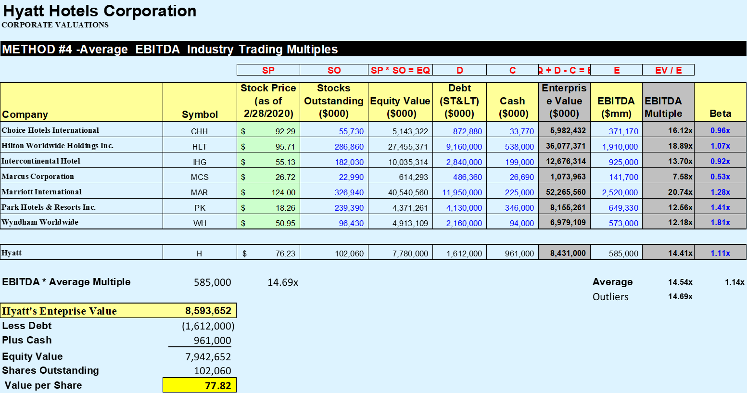

* + 1. Method 5: EBITDA Acquisition Multiple

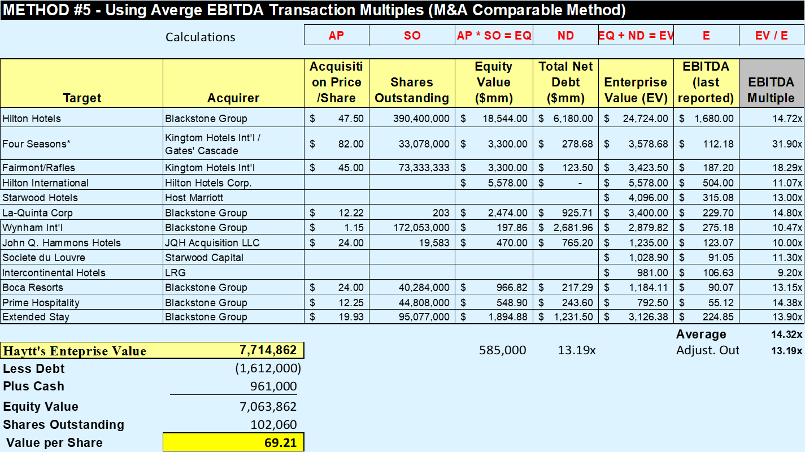

* 1. Method 6 (DCF but limited) public company valuation – the only thing you need to know is that if I give you the Stream Cash Flows and calculate the Terminal Value you can calculate the EV and stock price

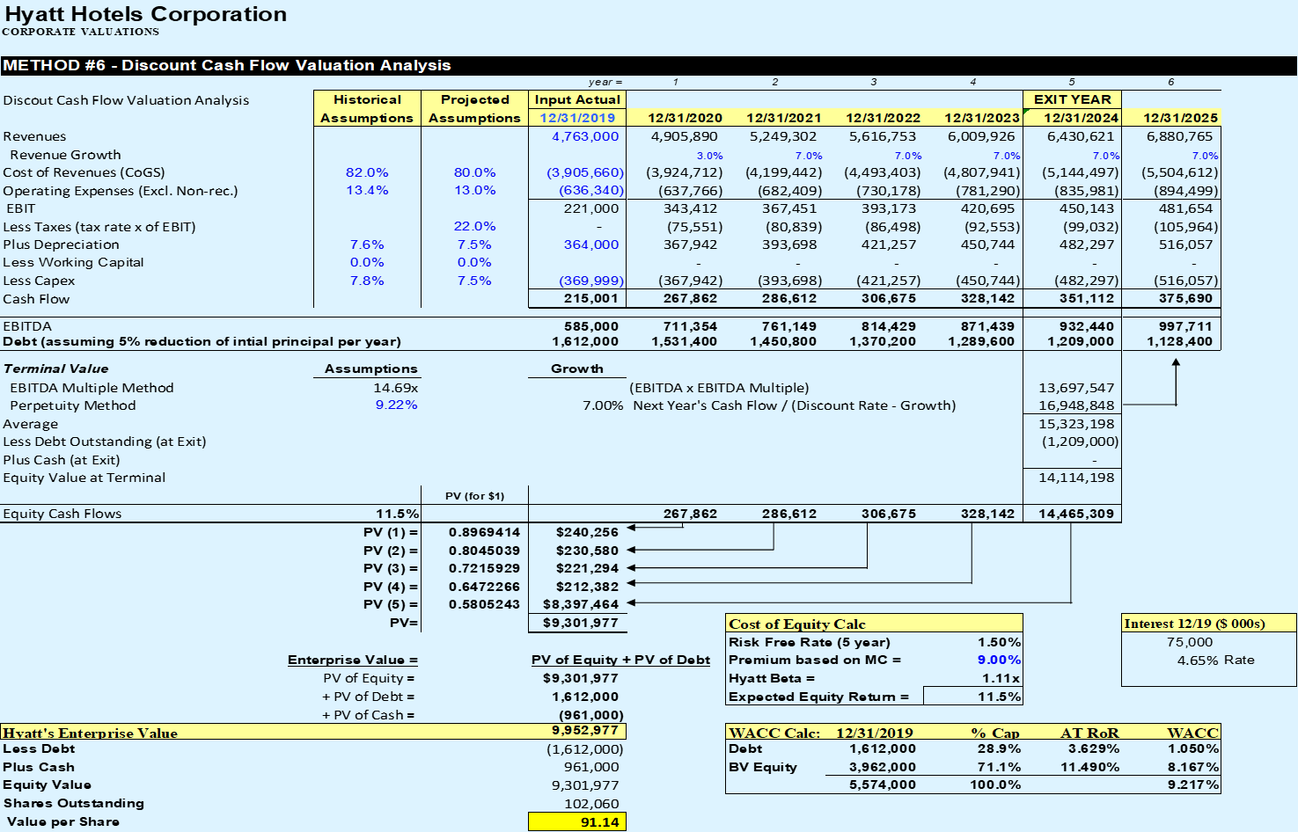

TIP: Know how to calculate CAPM, WACC, Terminal Values using EBITDA Multiples and Perpetuity Method